Thank you for your interest in the Greater Atlantic City Concierge Association! Please complete this application and return it. Once the application is processed, you will receive a badge and lanyard to be worn at all meetings.

Name: Title:

Company/Organization:

Job Description:

Address:
City: State: Zip Code:

Cell / Telephone Number: & Ext:
Fax Number:
Preferred E-mail address:
Referred by:
Can we add your name and place of work to our website on our members page? Y or N

Membership Type*: □ Concierge $35 □ Allied $65 □ Student (w/ School ID) $20
*Concierge members must be in a front line position: VIP, bell person, front desk, valet, etc. Allied members are professional partners associated with a restaurant, event venues, entertainment venues, etc. The more Concierge members we have, the more Allied members can join. All new members must be voted in by the Board before they are officially recognized as a member and may attend an event.

Email your application to gaccaboard@gmail.com. Once your Membership Application has been approved, you can pay your Membership Fees via the following options:

Scan the GACCA Membership QR Code: (Payments accepted are PayPal, Venmo, Credit & Debit Card)
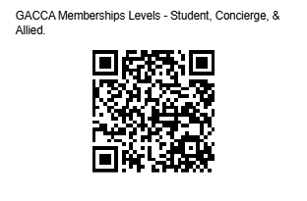
Our GACCA Website: Visit www.acconcierge.org. Click the “Buy Now” link on the bottom of the page.

By Mail: (Please include both your application and payment)
Greater Atlantic City Concierge Association
Attn: Jeanine Osendowski
PO Box 7102
Atlantic City, NJ 08401

We look forward to building a relationship with you! Please email or call if you need help or have any questions.
Jeanine Osendowski
609-437-5543

=========================================================================
For internal use only:

Application Accepted: Yes No Date: GACCA ID Number:

